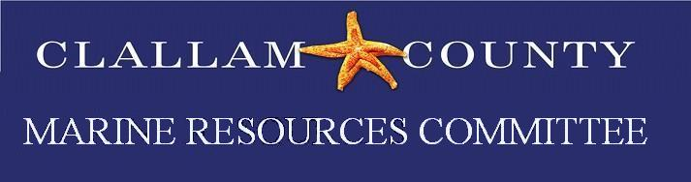
Draft Minutes
Date: Monday, November 15, 2021
Time: 5:30 – 7:00 pm
Location: Zoom meeting
Minutes prepared by Rebecca Paradis
Members present: P = Present E= Excused
P Bob Vreeland | P Robert Knapp | E Arnold Schouten | P Tim Cochnauer | ? Jesse Waknitz
P Ann Soule | E Jeff Ward | E Mike Doherty | P Latrisha Suggs | Makah Open Position
P Lyn Muench | P Alan Clark | P Ed Bowlby | P Ann Stafford | LEKT Open Position
Alternates present:
P Mary Sue Brancato | P Chris Burns | P Lance Vail
P Ioana Bociu | ? Navarra Carr
Ex-Officio Members / MRC staff/Members of the Public Present
Rebecca Paradis, Clallam MRC Coordinator/Habitat Biologist; Cathy Lear, Clallam Habitat Biologist Manager; Joseph Stride, Coleman Byrnes Nancy Stephanz.
Call to Order/Introductions/ Changes to Agenda
Call to order at 5:37. Mary Sue Brancato wanted to ad and admin item and project update.

Public Comment/Approval of Minutes
No public comment. Minutes for September and October were approved.

NWSC Update
Alan reminded the group about the NWSC virtual Climate Change Symposium is November 18th from 3:30- 5:00. Future NWSC Symposium dates are Dec. 16. Jan.20 and Feb. 17 all beginning at 3:30. Alan informed us that the Snohomish MRC removed 4 derelict boats. Alan also mentioned the Seabin Project, one of which was being used in Friday Harbor to capture plastic refuse in the harbor. The San Juan MRC spokesperson reported that they were happy with clean-up, didn’t see adverse interactions with sea life. Some problems with them were the cost ($3,000-5,000) and they last approximately 3-4 years, need power nearby and the need for daily trash collection.
Budget Updates: Rebecca Paradis let the CMRC know that she was working with Whidbey Audubon Society and Lori to get CMRC’s $400(approved in October) donation to the Salish Sea Guillemot Network.
Project Updates
Forage Fish: Tim has continued with surveys at Elwha and Cline Spit.
Kelp Survey: Alan- He is going to start working on methods for motorized surveys and Rebecca will be working on QAPP for motorized surveys.
Pigeon Guillemot: Ed said he is continuing to work out bugs with WDFW on their database.
Oil Spill: Ann Stafford is going to send out an email with information on Oiled wildlife response training, Pacific States task force meeting. She also explained how to sign up to volunteer on the Oil Spills 101 page.
Education/Outreach: Rebecca- Educational/Outreach cards arrived today and can be picked up at Olympic Printers.
Good of the Order
Rebecca- Three new applications for open positions were received. Raymond Kirk, alternate At large member, Nancy Stephanz, Conservation/Environmental alternate. Nancy was in attendance and she is hoping to start working on the WDFW SoundToxins project once she retires. She mentioned working with and getting training from Betsy Carlson and Neil Harrington.

Robert Knapp- mentioned that Neil Harrington is still catching green crab in the mouth of Jimmycomelately Creek creek. He also mentioned that JST hopes to take possession of their new Oil Spill Response Vessel in December.

Lyn- Asked Robert if Neil was monitoring for green crab anywhere else. Robert said yes, Chicken Coop creek and Washington Harbor. WDFW has sent a response team. Ed mentioned that he monitors in Sequim Bay near the mouth of Jimmycomelately creek. The consensus was to ask Neil Harrington to give a presentation on his green crab monitoring.

Public Comment
No public comment.

Adjourn
The meeting was adjourned at 6:38 pm.

