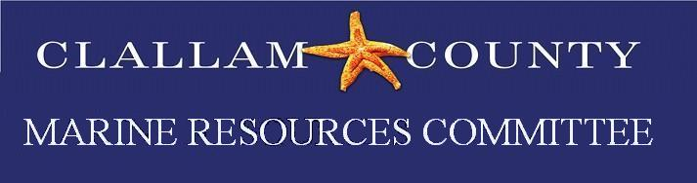
Meeting Minutes
Date: Monday, October 18, 2021
Time: 5:30 – 7:00 pm
Location: Zoom meeting
Minutes prepared by Rebecca Paradis
Members present: P = Present E= Excused
P Bob Vreeland | P Robert Knapp | P Arnold Schouten | P Tim Cochnauer | ? Jesse Waknitz
E Ann Soule | E Jeff Ward | P Mike Doherty | P Latrisha Suggs | Makah Open Position
E Lyn Muench | P Alan Clark | P Ed Bowlby | P Ann Stafford
Alternates present:
E Mary Sue Brancato | P Chris Burns | P Lance Vail
E Ioana Bociu | ? Navarra Carr
Ex-Officio Members / MRC staff/Members of the Public Present
Rebecca Paradis, Clallam MRC Coordinator/Habitat Biologist; Cathy Lear, Clallam Habitat Biologist Manager; Sasha Horst, NWSC; Joseph Stride, Coleman Byrnes and Cindy Hansen, Orca Network.
Call to Order/Introductions/ Changes to Agenda
No changes to the agenda.

Public Comment/Approval of Minutes
No public comment was made. The minutes for September were tabled until November.
Guest Speaker Cindy Hansen
Cindy Hansen is the Education and Advocacy Coordinator for the Orca Network and gave a presentation titled “Preventing Extinction: the Story of the Southern Resident Orcas.” Cindy’s presentation was very informative and educational about the Orcas that call the Puget Sound/Strait of Juan de Fuca home.

NWSC Update
Alan gave an update on Reauthorization, Congressional Directed Spending and Federal Appropriations. The NWSC virtual conference is November 18, 2021.
Budget Updates: Rebecca Paradis gave an updated the CMRC that the Northwest Straits agreement is due to be signed by Clallam County BOCC on October 26th.
Project Updates
Olympia oyster Restoration: Chris Burns gave a short Power Point presentation showing graphs of the pre and post “heat dome” surveys.
Forage Fish: Tim has continued with surveys and his preliminary findings are 1 egg Ediz hook, 1 egg Elwha and 500+ eggs at Cline Spit.
Kelp Survey: Alan- Kelp data is assembled and has been sent in. He is going to start working on methods for motorized surveys.
Pigeon Guillemot: Ed said surveys were wrapped up in September and data has been entered in WDFW regional data base (Guillemot network). He also stated that he and Rebecca has a call with NWSC and WDFW about how to get data into SoundIQ. He also asked the CMRC to once again sponsor the regional Pigeon Guillemot coordinator @ $400. Arnold moved and Alan seconded the motion.
Oil Spill: Ann Stafford is going to look into what other MRC’s have applied for regarding funding for Oil Spill/Hazewoper training.
Education/Outreach: Rebecca is going to place order for 1000 each of 3 designs once final bid comes in.
Good of the Order
Mike Doherty- Pacific Coast Fisheries management team needs more members. DOE comment period on Rosario Strait vessel traffic. LaTrisha asked for Mike to send the DOE proposals and he directed her to the DOE website.

Public Comment
No public comment.

Adjourn
The meeting was adjourned at 7:11 pm.

