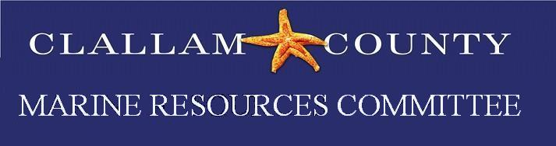
Draft April Minutes 2022
Date: Monday, April 25, 2022
Time: 5:30 – 7:00 pm
Location: Hybrid Zoom/ In person meeting
Minutes prepared by Rebecca Mahan
Members present: P = Present E= Excused
P Bob Vreeland | E Robert Knapp | E Arnold Schouten | P Tim Cochnauer | P Jesse Waknitz
P Ann Soule | P Jeff Ward | E Mike Doherty | P Latrisha Suggs | Makah Open Position
E Lyn Muench | P Alan Clark | E Ed Bowlby | P Ann Stafford | P Justin Stapleton
Alternates present:
E Mary Sue Brancato | P Chris Burns | E Lance Vail | P Raymond Kirk
P Ioana Bociu | ? Navarra Carr | E Nancy Stephanz
Ex-Officio Members / MRC staff/Members of the Public Present
Rebecca Mahan, Clallam MRC Coordinator/Habitat Biologist; Kara Cardinal, Strait ERN LIO Coordinator;
Call to Order/Introductions/ Changes to Agenda
Call to order at 5:36 by Tim Cochnauer.

Public Comment/Approval of Minutes
- March meeting minutes approved.
Interns 2022: Intern flyer will be put together and two intern positions will be advertised.

NWSC Update: Alan Clark gave Updates:
- Northwest Straits MRC Conference in LaConnor, WA November 18-19 it is tentatively an in person event.

Port Angeles Earth Day: Very successful there were over 17 groups participating and we had several new volunteers sign up.

Derelict vessel update: Rebecca Mahan was going to work with Jesse Wakintz on derelict vessels in Clallam County.

Storm surge/King tide update: Tim Cochnaur, Alan Clark, and Jeff Ward are drafting a white paper.

Project Updates:
- Olympia oyster: Heat map surveys May 31-June 2 cancelled.
- Biotoxin: Bob Vreeland getting biotoxin supplies from DOH and planning on sampling the Pillar Point. Coleman Byrnes will be sampling Freshwater Bay.
- Forage Fish: 3 surf smelt eggs w.
- Pigeon Guillemot: Ed Bowlby is recruiting for volunteers.

Good of the Order:
- Mike Doherty mentioned the Olympic Coast National Marine Sanctuary as a resource. As NOAA / Sea Grant as guest speakers for future MRC meetings.
- Tim Cochnaur mentioned that he was impressed with the questions from the BOCC after his presentation. It was suggested that each MRC member leading a project give a presentation to the BOCC as well as Lucas Hart speak to the CDS/Reauthorization funds.

Public Comment:
Adjourn
The meeting adjourned at 6:38 pm.

