CLALLAM MRC RETREAT SPECIAL MEETING AGENDA
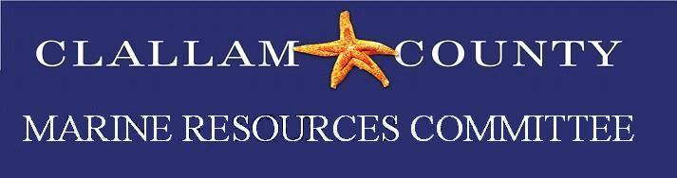 | February 23, 2023  10:00 a.m. – 3:00 p.m.  Hybrid Meeting
Dungeness River Nature Center
1943 W Hendrickson Road
Sequim, WA 98382

Zoom Meeting Link: https://us06web.zoom.us/j/83421957710
Meeting ID: 834 2195 7710
Passcode: 12345

Please RSVP to Rebecca Mahan at Rebecca.mahan@clallamcountywa.gov
If you have dietary restrictions, please make that know when you RSVP

10:00 AM – 10:35 AM Welcome and Introductions

10:40 AM – 10:50 AM Role of the Marine Resource Committees

10:50 AM – 11:00 AM Review Retreat Objectives

11:05 AM – 12:00 PM Objective 1 – Review Accomplishments & List New Projects

12:00 PM – 12:34 PM Networking Lunch – Lunch will be provided so members can connect and continue brainstorming.

12:40 PM – 1:30 PM Objective 2 - Clarify Administrative & Clerical Roles & Needs

1:35 PM – 2:35 PM Objective 3 – Prioritize Activities

2:40 PM – 2:55 PM Wrap – Up / Closing Remarks

3:00 PM Adjourn

