CLALLAM MRC MEETING AGENDA
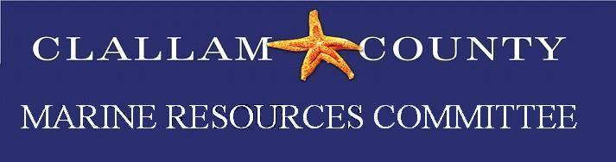 | February 27, 2023  5:30 p.m. – 7:00 p.m.  Hybrid Meeting

Zoom Meeting Link: https://us06web.zoom.us/j/86570354388
Meeting ID: 865 7035 4388
Passcode: 12345

For more information about the MRC, please contact Rebecca Mahan at (360) 417-2322

5:30 Welcome by Chair Tim Cochnauer

5:35 Call To Order / Introductions / Changes to Agenda

5:40 Public Comment / Approval of Minutes
Approval January minutes.

5:45 NWSC Update
NWSC monthly meeting – Alan Clark

5:50 February Retreat Updates

6:50 Project Updates
Olympia oysters: CDS shell placement - working on permits JST and CC
Forage Fish: Survey updates.
Other project updates:
.
6:50 Good of the Order
6:55 Public Comment
7:00 Adjourn

