CLALLAM MRC MEETING AGENDA
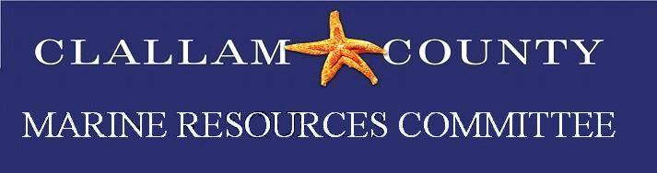 | March 20, 2023  5:30 p.m. – 7:00 p.m.  Hybrid Meeting | 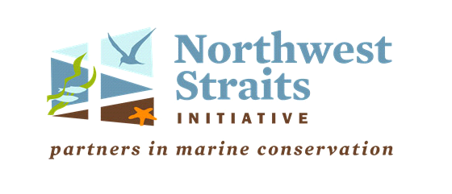

Zoom Meeting Link: https://us06web.zoom.us/j/86570354388
Meeting ID: 865 7035 4388
Passcode: 12345
For more information about the MRC, please contact Rebecca Mahan at (360) 417-2322

5:30 Welcome by Chair Tim Cochnauer
- Motion to order more coasters
- Motion to order new GPS for kelp project
- Motion to order event tabling supplies (rack card holders)

5:35 Call To Order / Introductions / Changes to Agenda

5:40 Public Comment / Approval of Minutes
Approval February minutes.

5:45 NWSC Update
NWSC monthly meeting – Alan Clark

5:50 NWSC RFP for 2023-2025 – Discuss new and current projects.
Current Projects:
- Forage Fish
- Pigeon Guillemot
- Olympia Oysters Restoration
  - CDS shell placement project
- Kelp monitoring
- Education/Outreach
- Elwha Beach Stewardship
- Biotoxins
New Project ideas:
- Pinto Abalone – Pilot survey study
- Sound Toxin collaborating with Feiro
- Continuing shell placement project and add seeded clutch
- Valley Creek pocket beach/estuary noxious weed control/ native planting

6:50 Project Updates
Updates as necessary
6:50 Good of the Order
6:55 Public Comment
7:00 Adjourn

